Introduction

- reporte cohesion social 2012

Theoretical views on social cohesion, group characteristics, and social interactions

Views on Social Cohesion

Social cohesion is a multifaceted concept with various definitions in the social sciences.Ha estado presente tanto en la investigación académica como en la elaboración de políticas.
Entre estas definiciones han estado aquellas más centradas en la dimensión sistémica, relacionado con aspectos como la (des)integración y estabilidad social, mientras que otras perspectivas han estado centradas en la dimensión individual y grupal.
Un estado, no un proceso.
solidaridad orgánica y solidaridad mecánica. La primera se refiere al «acceso a condiciones económicas y gubernamentales formales», mientras que la segunda se refiere al «acceso a relaciones familiares y comunitarias, cara a cara».
Indeed, quality of life and demographic characteristics may be constitutive of cohesion, but they are not cohesion itself.
X ejemplo, la satisfacción con la vida sería más bien una causa de la cohesión, así también las dimensiones demográficas como la composición y motivos para moverse/quedarse en un lugar.
La cuestgion sobre si las condiciones estructurales (redes) de las relaciones sociales son antecedentes de lo que ocurre a nivel individual en la identidad, apego, actitudes, etc
“Theories of social cohesion may never be fully developed if they focus on the explanation of the independent responses of persons to particular conditions and do not describe how group members interact and influence each others’ membership attitudes and behaviors.” (Friedkin, 2004, p. 422)
“Social relations also encompass relations between various groups within a society, whether cultural, ethnic, or groups with a certain lifestyle or sexual orientation.” (Schiefer and Noll, 2017, p. 588)
“Values such as respect, tolerance, or humanity (i.e., self-transcendence values a ́ la Schwartz 1992) are often proposed.” (Schiefer and Noll, 2017, p. 590)
“In Bernard’s approach, social cohesion consists of three main domains: political, sociocultural and economic. In the framework of Chan et al. two main dimensions are considered: a horizontal dimension (cohesion within civil society) and a vertical one (cohesion between state and citizen). Going one step further, Chan et al. distinguish three main vertical levels at which social cohesion can be measured: the micro (i.e. individual), mezzo (i.e. group) and macro (i.e. state) levels. In other words, social cohesion can be approached through relationships between individuals, between groups and individuals and between state institutions and individuals” (Dickes et al., 2010, p. 454)

https://www.annualreviews.org/content/journals/10.1146/annurev-soc-030420-015435
https://www.cambridge.org/core/journals/political-analysis/article/measurement-of-crosscutting-cleavages-and-other-multidimensional-cleavage-structures/F8F8F4C3193BEABBD322C8DDD824B3C6#article

Group characteristics and social interactions

Socioeconomic inequality (Class and status differences)
- neo-materialist theory: those with fewer resources are less able to establish trustworthy relationships with others beyond their close ties

Cultural diversity
- Ethnicity, Religion

The politico-normative domain
- Political identity and human values
- Diversity and shared values
- Do shared values affect social cohesion?

“The essential features of social cohesion are (1) the quality of social relations (including social networks, trust, acceptance of diversity, and participation), (2) identification with the social entity, and (3) orientation towards the common good (sense of responsibility, solidarity, compliance to social order)” (Schiefer and Noll, 2017, p. 595)

Homophily as a Cross-Cutting Mechanism

Paragraph 1 (Theory):
Define homophily (McPherson et al., 2001): preference for similar others across SES, ethnicity, religion, politics, and values.
Mechanisms: cognitive consistency, similarity-attraction paradigm.
Expected effect: similarity amplifies trust and cooperation, reduces conflict.
(~250–300 words)

Paragraph 2 (Empirical Evidence):
Homophily is documented in networks and attitudes (Otero et al., 2022; Salgado et al., 2021).
Evidence of stronger cohesion in homogeneous groups; weaker in diverse ones. (~250–300 words)

Current study
Figure 1: Theoretical model

Data, variables, and method

Data

Variables

Method
Compared to other studies (Grigoryan, 2022), we decided to include concrete demographically rooted categories fo all the addressed dimensions
Maybe use the Dominant Value Profile for each person?
Of the four types of values, which one is dominant/salient?

Results

The relationship between group characteristics and social cohesion
[Figure 1: Multilevel models for social cohesion and group characteristics]
Model 1: Trust
Model 2: Collaboration
Model 3: Conflict

Cross-group interactions and the homophily hypothesis
Figures with the predicted means for each cross-group interaction

Tables go to the supplementary material

# Lit review notes
Has education expansion increased social cohesion or diminished it?
- Hi: normative reinforecement as education expanded
- Hi: increasing cognitive capacities/skills have increases critical views
- There is a conditional question on these: I believe that educational expansion has increases social cohesion under conditions of low inequality
Table: Relationship between education and inequality on social cohesion
 | Low Expansion | High Expansion
Low Inequality | Weak or null | Reinforcement
High inequality | Null | Skepticism

- Structural cohesion refers to the structure of social relations represented by social networks. Between groups (bridging), within groups (bonding). This is a description of the structure of social relations. One can say this is an “objective” structural cohesion.
- Social cohesion refers to the set of principles and norms represented by attitudes and their behavioral expressions. Here we find trust (all types) and participation (all types). Distinctions can be traced among the lines of horizontal and vertical interactions.

- Repliegue por diversidad (Putnam). Esta sería contingente a los niveles de desigualdad.

- Are, rather epiphenomena of more basic factors.
“Putnam (2007) himself emphasizes that, in areas of high diversity, even nativeborn whites come to distrust one another.” (Portes and Vickstrom, 2011, p. 472)
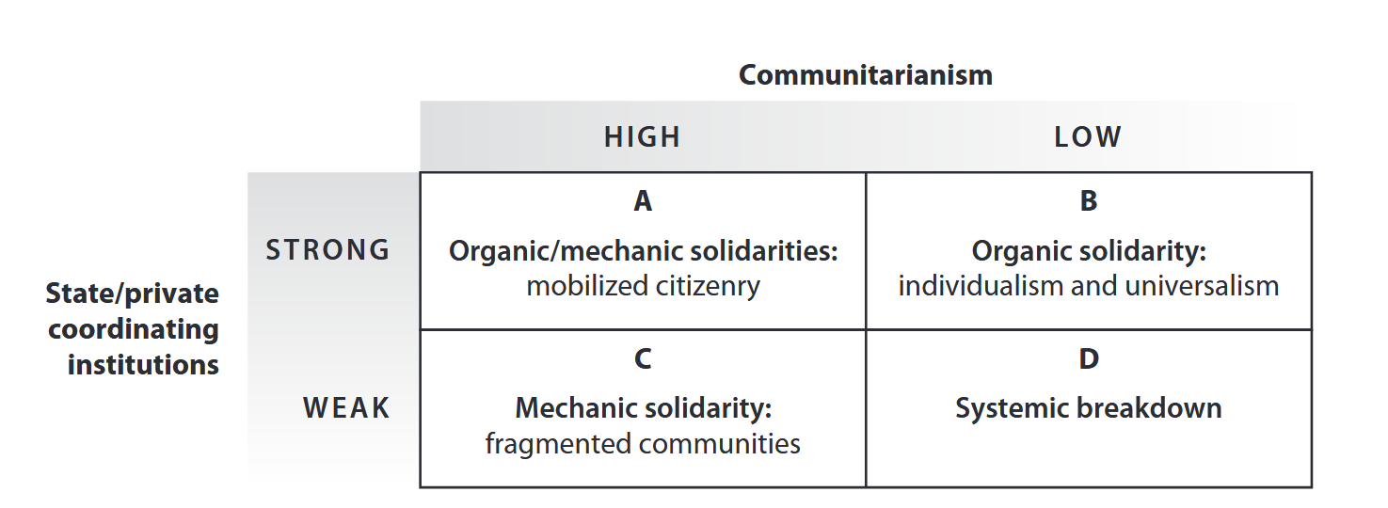
“Although communitarianism is an appealing ideal, it cannot provide the basis for the organization of a modern democratic society and, when practiced in excess, may actually threaten its stability.” (Portes and Vickstrom, 2011, p. 474)
Table: Relationship between governance and migration on social cohesion
 | Low migration | High migration
Low governance | Cohesive shaky | Fascism
High governance | Cohesive stable | Cohesive contentious

Putnam’s short term pessimism on the link between diversity and trust

